**Module – 5**

**1. How to Configure, Develop, and Maintain Security and Privacy in Cloud**

“Configuring, developing, and maintaining security and privacy in the cloud involves several best practices and strategies:

Shared Responsibility Model: Understand that cloud security is a shared responsibility between the cloud provider and the customer. Providers like AWS, Azure, and Google Cloud secure the infrastructure, while customers must secure their data, applications, and access controls.

Data Encryption: Encrypt data both at rest and in transit to protect it from unauthorized access. Use strong encryption protocols and manage encryption keys securely.

Identity and Access Management (IAM): Implement robust IAM policies to control who can access your cloud resources. Use multi-factor authentication (MFA) and least privilege principles.

Regular Audits and Compliance: Conduct regular security audits and ensure compliance with relevant standards like GDPR, HIPAA, and SOC .

Network Security: Use firewalls, VPNs, and intrusion detection/prevention systems to protect your cloud network. Monitor network traffic for suspicious activities.

Security Policies and Training: Develop comprehensive security policies and provide regular training to employees to ensure they understand and follow security best practices.”

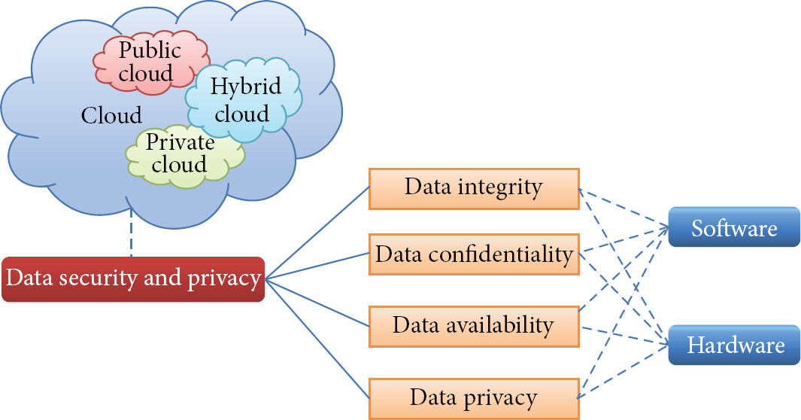

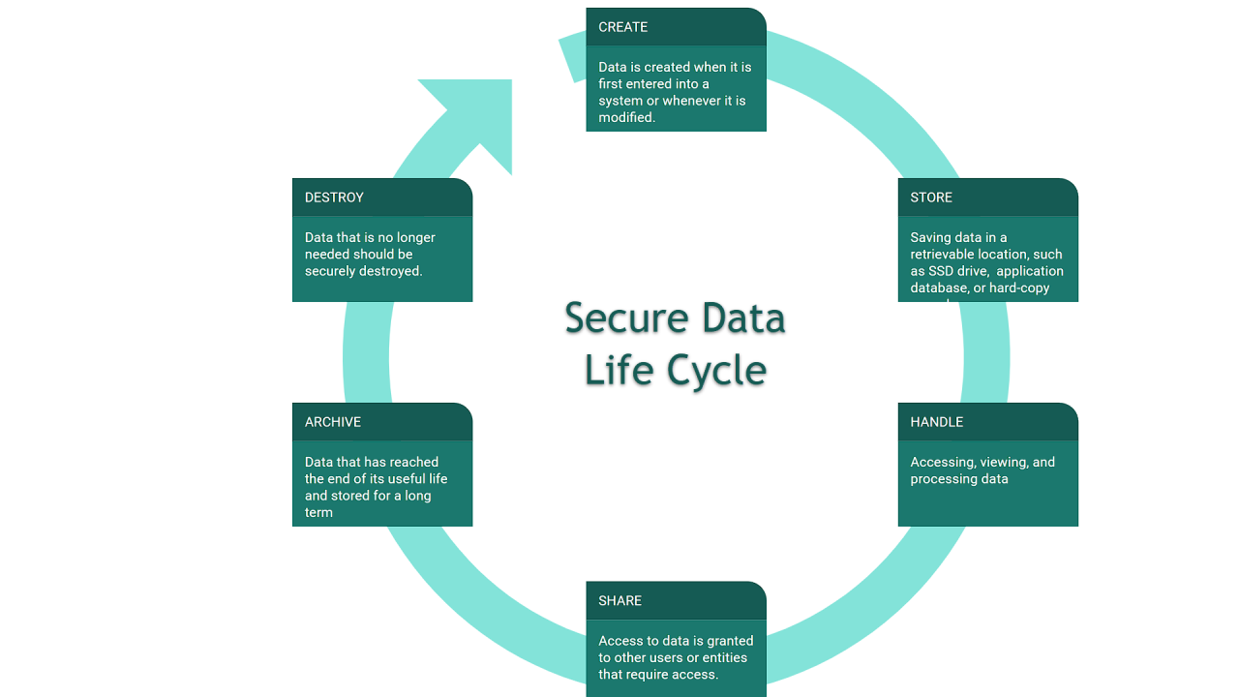

**2. What is Portability in Cloud?**

“Cloud portability refers to the ability to move applications, data, and services from one cloud environment to another with minimal disruption. This can involve moving from a private cloud to a public cloud, or between different public cloud providers. Key aspects include:

Data Portability: The ability to transfer data seamlessly between different cloud services without re-entering data.

Application Portability: The capability to move applications across different cloud platforms with minimal changes.

Ensuring that applications are not tightly coupled to a specific cloud provider’s services.”

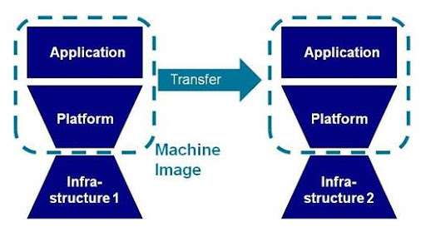

**3. What is Reliability and High Availability in Cloud?**

“Reliability in cloud computing ensures that cloud services perform consistently and correctly High availability refers to the ability of a system to remain operational and accessible even in the event of failures. Key strategies include:

Redundancy: Deploying multiple instances of services across different geographic locations to avoid single points of failure.

Auto-scaling: Automatically adjusting resources based on demand to maintain performance and availability.

Disaster Recovery: Implementing backup and recovery solutions to quickly restore services in case of failures.” 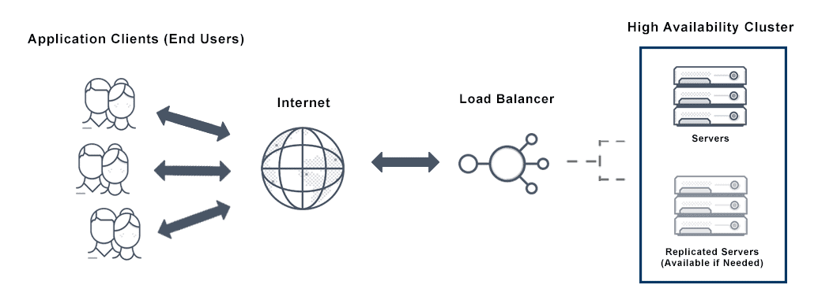

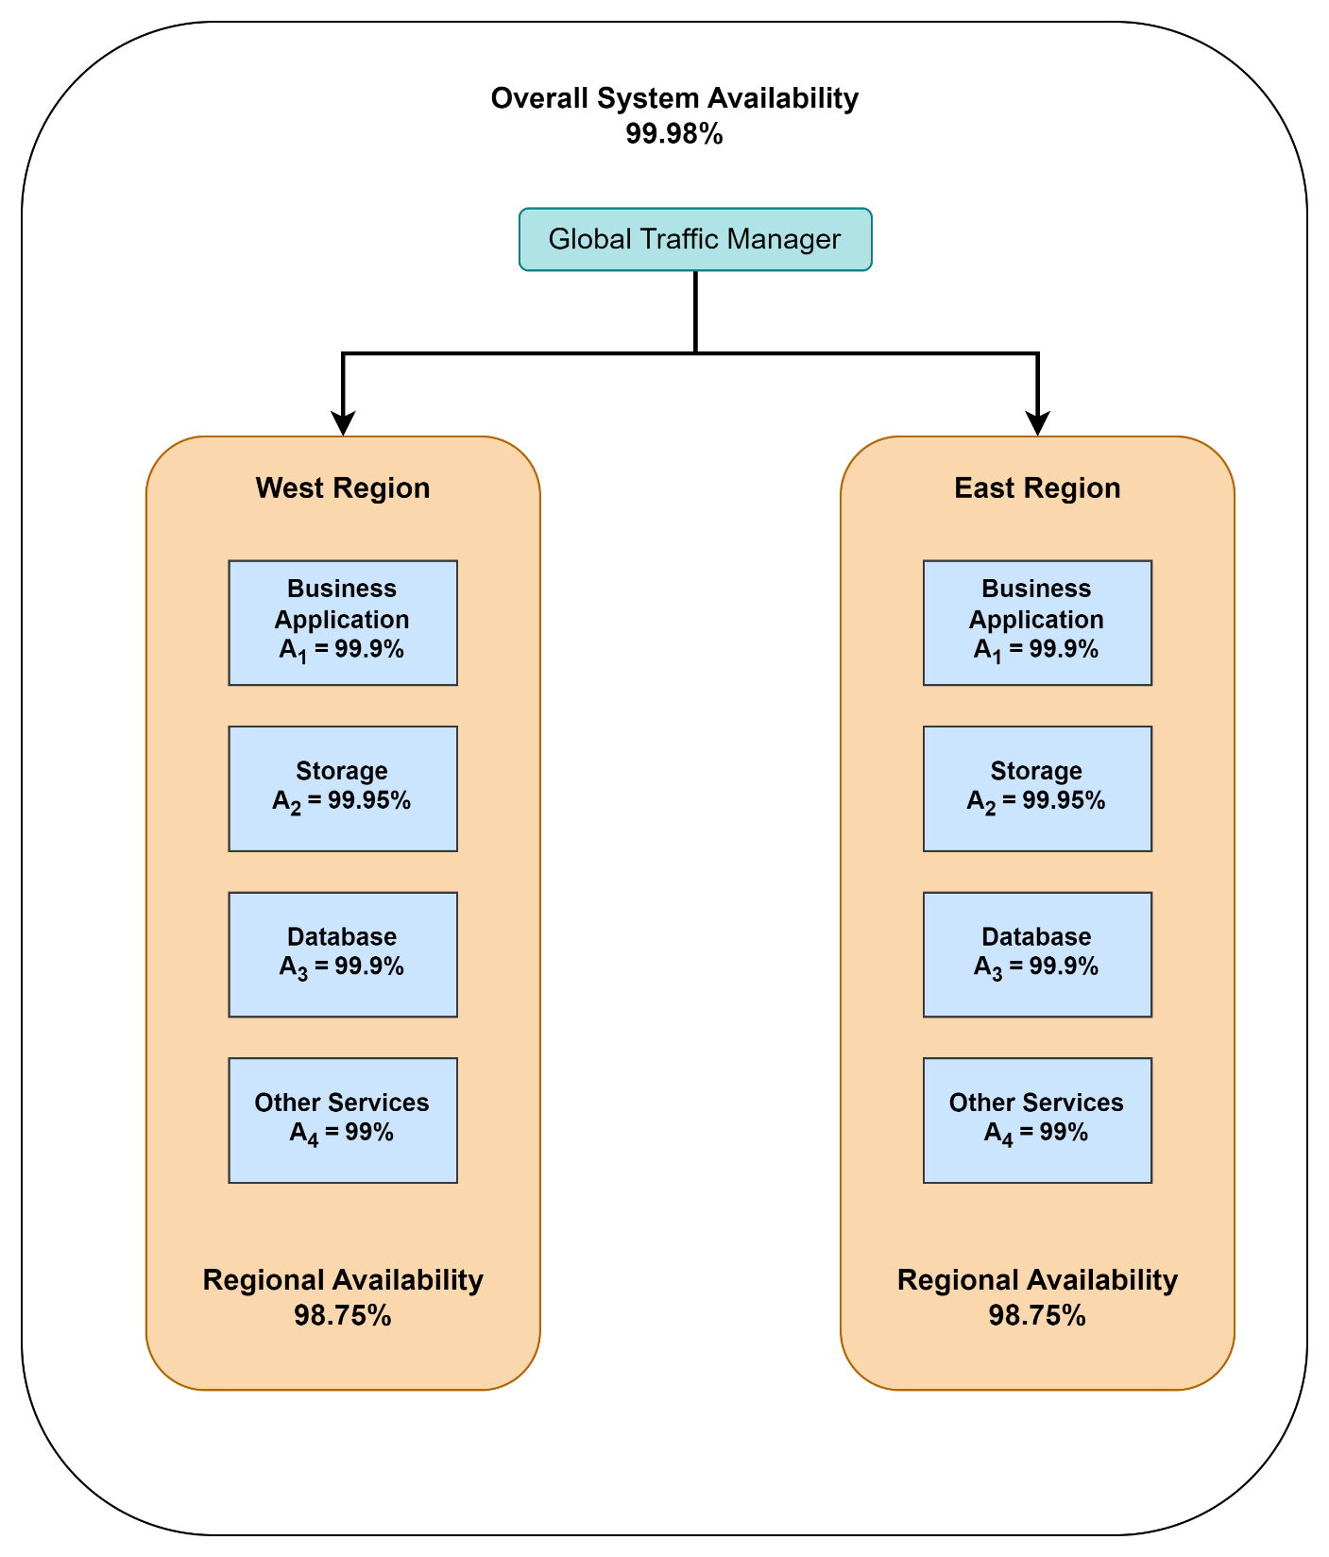

**4. Describe Mobility Cloud Computing**

“Mobile Cloud Computing (MCC) combines mobile computing and cloud computing to deliver applications and services to mobile devices. Key features include:

Resource Offloading: Offloading computational tasks to the cloud to reduce the burden on mobile devices.

Platform Independence: Applications can run on any device regardless of the operating system.

Real-time Data Access: Providing access to data and applications from anywhere, enhancing user experience.”

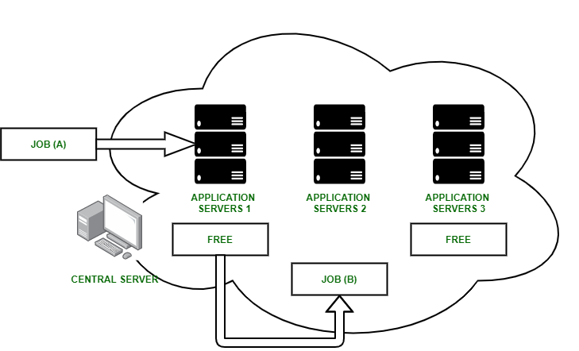

**5. Describe AWS, Azure, Google Cloud Platforms**

“Amazon Web Services (AWS), Microsoft Azure, and Google Cloud Platform (GCP) are the leading cloud service providers, each offering unique features:

AWS: Known for its extensive range of services and global reach. It offers scalable storage, computing power, and a wide array of tools for developers.

Azure: Integrates well with Microsoft products and services. It provides robust solutions for enterprise applications, AI, and machine learning.

Google Cloud: Excels in big data analytics and machine learning. It offers seamless integration with other Google services and strong support for containerized applications.”

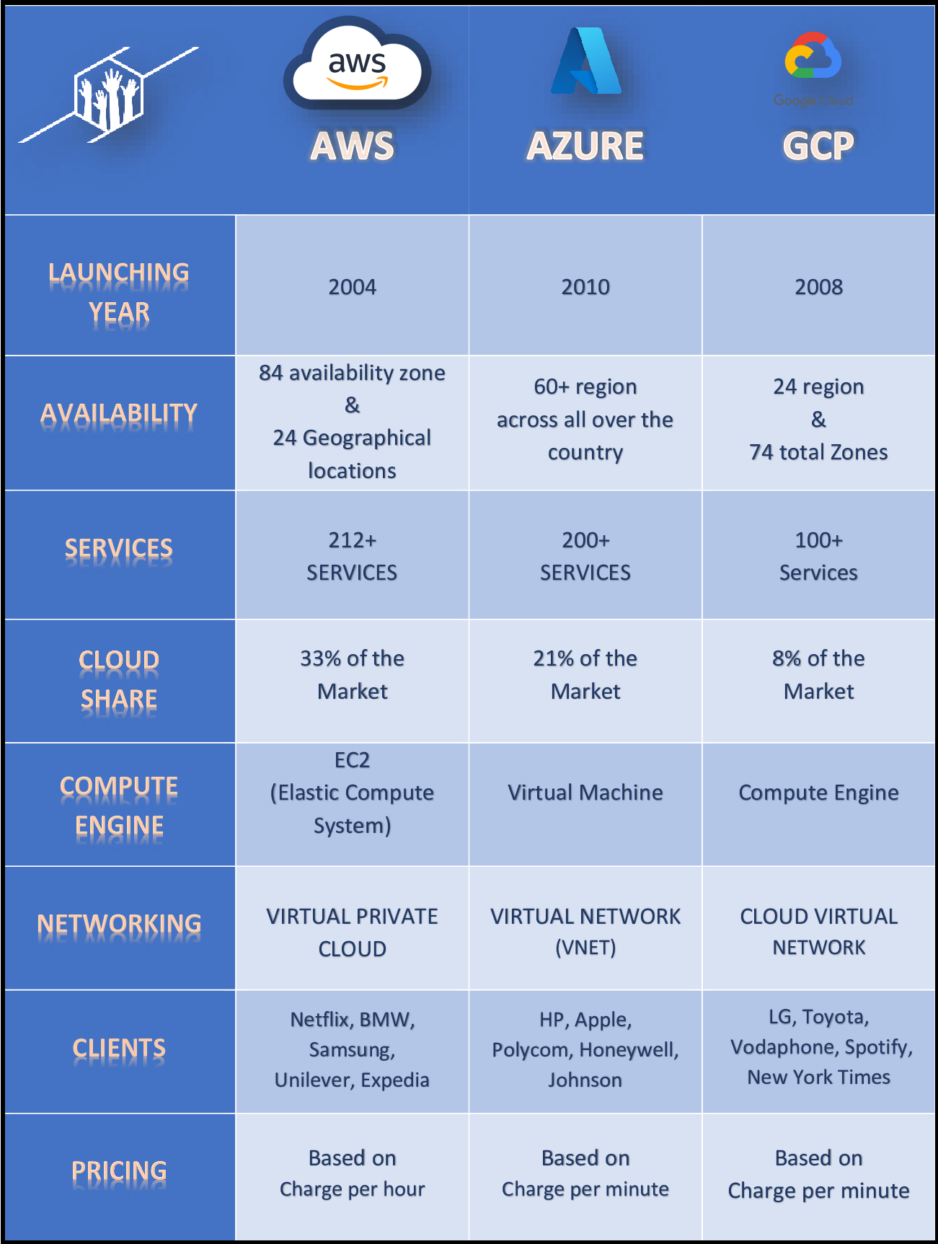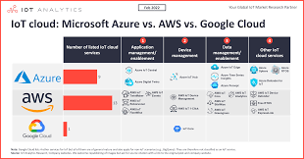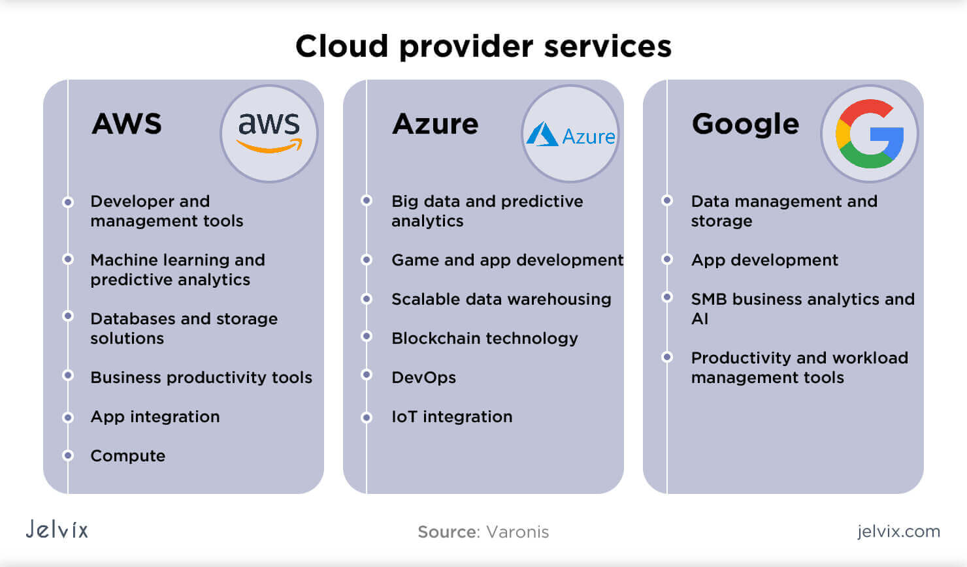

**6. Accessing AWS, Azure, and Google Cloud Platforms**

“To access any of these cloud platforms, you need to create an account and sign in through their respective portals:

AWS: Go to the AWS Management Console. If you don’t have an account, you can create one and start with the AWS Free Tier.

Azure: Visit the Azure Portal. You can sign up for a free account which includes $200 in credits for the first 30 days.

Google Cloud: Access the Google Cloud Console. New users can get $300 in free credits to use over the first 90 days.”

**7. Create Compute, Network, and Storage on AWS, Azure, and GCP**

“

AWS

Compute: Use Amazon EC2 to launch virtual servers. Go to the EC2 Dashboard, click “Launch Instance,” and follow the steps to configure your instance.

Network: Set up a Virtual Private Cloud (VPC) by navigating to the VPC Dashboard and creating a new VPC.

Storage: Use Amazon S3 for object storage. Go to the S3 Dashboard, create a new bucket, and upload your files.

Azure

Compute: Create a Virtual Machine (VM) from the Azure Portal. Click “Create a resource,” select “Virtual Machine,” and configure your VM.

Network: Set up a Virtual Network (VNet) by navigating to the “Virtual networks” section and creating a new VNet.

Storage: Use Azure Blob Storage. Go to the “Storage accounts” section, create a new storage account, and then create a blob container.

Google Cloud

Compute: Use Google Compute Engine to create VM instances. Go to the Compute Engine section, click “Create Instance,” and configure your VM.

Network: Set up a Virtual Private Cloud (VPC) by navigating to the VPC network section and creating a new VPC.

Storage: Use Google Cloud Storage. Go to the Cloud Storage section, create a new bucket, and upload your files.”

**8. Compare Cloud Pricing of Resources and Services on AWS, Azure, and GCP**

“Comparing cloud pricing can be complex due to the different pricing models and services offered by each provider. Here’s a general comparison:

AWS

Pricing Model: Pay-as-you-go, with options for reserved instances and savings plans.

Compute: On-Demand pricing for general-purpose instances starts at around $0.0116 per hour for t4g.micro instances.

Storage: Amazon S3 standard storage costs approximately $0.023 per GB per month.

Azure

Pricing Model: Pay-as-you-go, with reserved instances and spot pricing.

Compute: On-Demand pricing for general-purpose instances starts at around $0.008 per hour for B1s instances.

Storage: Azure Blob Storage standard costs approximately $0.0184 per GB per month.

Google Cloud

Pricing Model: Pay-as-you-go, with committed use contracts.

Compute: On-Demand pricing for general-purpose instances starts at around $0.010 per hour for e2-micro instances.

Storage: Google Cloud Storage standard costs approximately $0.020 per GB per month.

Each platform offers various discounts and pricing options, so it’s essential to use their pricing calculators to get an accurate estimate based on your specific needs:

AWS Pricing Calculator

Azure Pricing Calculator

Google Cloud Pricing Calculator ”